**NSF Graduate Fellowship Proposal**

**Implementation of Experimental Design Skills in Undergraduate Chemistry (STEM Education & Learning)**

**Nafis Mukut**

The GPA of STEM majors has shown a continued drop for more than a decade. This has been a noticeable trend since as early as the 90’s, with Chemistry traditionally having the lowest average GPA of most, if not, all STEM majors.

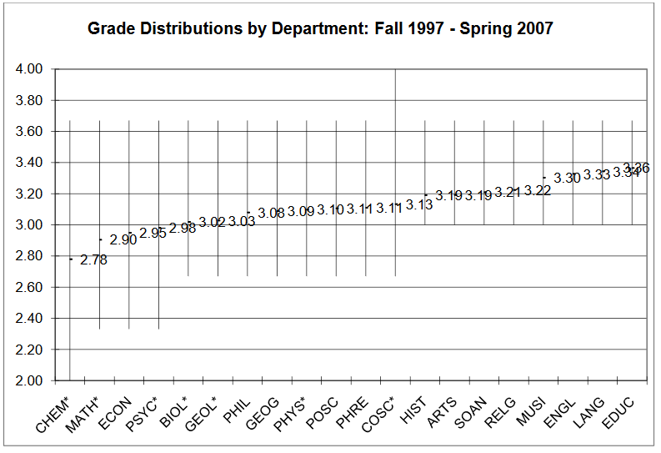

**Figure 1.** Grade distributions by department from Wake Forest Univeristy.1

In correspondence with this evident drop in average GPA, there has been an overall decreasing trend in students entering into STEM majors.

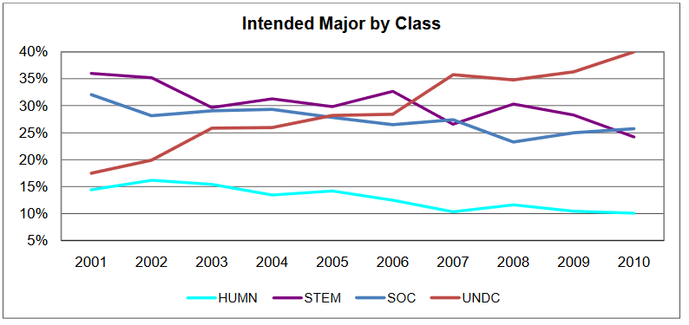

**Figure 2.** Intended majors for incoming first year students at Wake Forest University.1

Whilst practices such as GPA inflation somewhat mediate the downward GPA trend for STEM majors, this doesn’t fully counteract the main consequence of the association between low GPAs and STEM majors; the discouragement of incoming students from taking up those majors.

Many scientists have conducted research in order to propose various methods to address concerns such as this one, as well as further develop the teaching environment for Chemistry. My research intends to add to these methods and to clearly focus on encouraging students to engage in and remain in the Chemistry major by endeavoring to reinforce their confidence in the field.

This research aims to demonstrate how students can potentially develop a stronger foundation in chemistry (more specifically, with lab work) by developing their own methodology for an experiment. This is typically done so by having students essentially create/complete an experiment on their own. Whilst this is a commonly done practice in most universities/classes, it’s evident that this isn’t enough to make a student feel confident enough to make a career out of chemistry. As such, it's imperative to integrate the idea of industry into academia; have students perform these experiments, and have them create proposals in order to apply them to the world of industry. If they can make a clear connection between what they do in the classroom, and what’s done in the real world, theoretically, they should feel more confident in their major.

Procedure-wise, one class from each level of each chemistry course would be given additional proposal assignments in order to apply their lab work in the classroom to a career-based environment. The subsequent understanding that these students will then have gained can then be demonstrated by testing these students as well as the students who didn’t receive these assignments based on applications of lab work scaled up.

**Intellectual Merit**

    This research work would demonstrate the actual importance of industry in the world of academia, mainly by demonstrating the effect of industry on the retention rate of students. If a student can recognize the potential for a career with this major, then they’ll want to stay. Based on this demonstration of this value, further research into the education of future chemists can then include more or less industry-oriented factors into their work.

**Broader Impact**

    The unemployment for chemists in the United States has been a consistent 8% or so. It is of my belief that a major factor behind this is that students who have only just graduated, are unable to initially apply their research/classroom experiences from university into any future careers they seek. As such, this research can either disprove that factor entirely, or demonstrate how necessary it is to keep industry and other career-work in mind from the very first year of college. A huge potential change could be the creation of course work specifically to teach students how industry works.

**References**

Rask, K. Attrition in STEM Fields at a Liberal Arts College: The Importance of Grades and Pre-Collegiate Preferences. *Economics of Education Review* **2010**, *29* (6), 892–900